A/P 1099 Forms (1099)

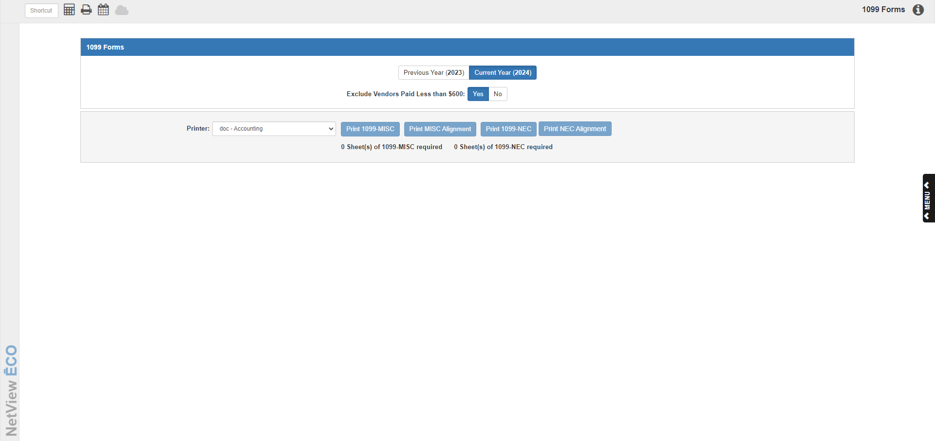

If you have to file 1099 forms for any of your vendors, this function prints them for you. It checks each vendor’s settings to see if you have indicated that you want to print a 1099 form for that vendor. It also checks the YTD Paid and Previous Year Paid fields (depending on which year being printed) in the Vendor’s Information file to verify that the amount meets the requirement for printing 1099 forms ($600 at present).

To access this function, you can either:

* Select “Accounts Payable” from the menu. Choose the “Memo Reports” submenu and click “1099 Forms.”
* Type “1099” in the Shortcuts Bar

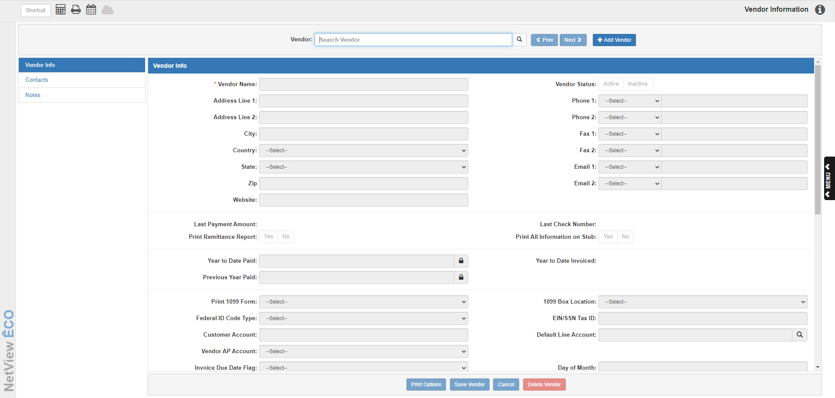

The data for the 1099 Forms comes from the Year to Date Paid field in Vendor Information (VIM). Every time you make a payment or check entry, the amount of the check updates this field. When the new calendar year starts, the value is moved to the Previous Year Paid field, so you will still have access to it for another calendar year. Additionally, you can now set the specific box location on the form where you want your information to print. **NOTE:** To print a 1099 for that vendor account, the **1099 Form** field in VIM must be set to **Yes**.

### 

**Before you print the 1099 Forms, print this information on plain paper or using the “pdf-Display” printer so that you can verify that all of the vendors requiring this form are included.** If you find that vendors are missing from this printout, you can review their vendor information. Typical reasons why vendors are missing from the printout are:

* Total payments for the year were under the required 1099 amount ($600).
* Payment entries for the year are incomplete. For example, maybe one or more invoices are still on the vendor’s account as unpaid.
* The amount in the YTD Paid or Previous Year Paid fields in VIM was incorrect.
* The default in the Print 1099 Form was set to **No** for this vendor.

**Running 1099:** At this point, load the 1099 Forms in your printer. The message below the printing options will tell you how many form sheets are required for the print run.

### Previous Year/Current Year: Indicate whether the forms to be printed are for the previous or current year. The actual current and previous years will also show on the buttons to make it clear which calendar years are used.

### If you are printing your forms before January 1st of the new calendar year, select Current Year, as the amount has not recalculated yet.

### If you are printing your forms after January 1st, select Previous Year, as the YTD Paid value will have moved to the Previous Year Paid field on January 1st. NOTE: Make sure to run the Disbursement Journal (DJ) prior to printing forms so your amounts are correct.

### Exclude Vendors Paid Less than $600:

* This field defaults to **Yes** to exclude vendors with less than $600 in payments during the year. Currently, the federal minimum is $600.
* Choose **No** to print 1099 forms for vendors with less than $600 in payments.

### Printer: A default printer is pre-filled but you can select another one.

### Print 1099-MISC: Press this button to print the 1099-MISC forms, which are the main 1099 forms. If any vendor requires a 1099 form, they will always receive this form, only receiving the 1099-NEC form if that is so indicated on their VIM page. NOTE: If none of your vendors require a 1099-MISC form, this button will be disabled.

### Print MISC Alignment: Press this button to print a sample 1099-MISC form only. NOTE: If none of your vendors require a 1099-MISC form, this button will be disabled.

### Print 1099-NEC: Press this button to print the 1099-NEC forms, which are newly-required (starting in 2020) auxiliary forms for non-employee compensation amounts. VIM now specifically lets vendors select “NEC” as their box designation to indicate they need to receive this form as well as the 1099-MISC form. NOTE: If none of your vendors require a 1099-NEC form, this button will be disabled.

### Print NEC Alignment: Press this button to print a sample 1099-NEC form only. NOTE: If none of your vendors require a 1099-MISC form, this button will be disabled.

**Sample 1099-MISC Form:**

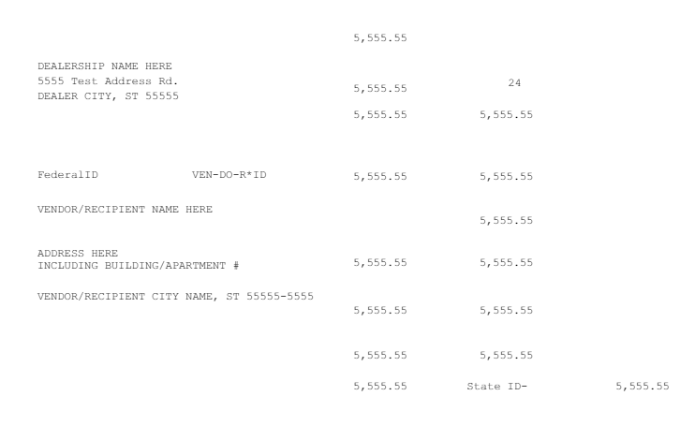

**Sample 1099-NEC Form:**

